Name: ___________________

Number: 1 - ___ - ___

Are you from Kitakyushu?

Are you....?

**例**

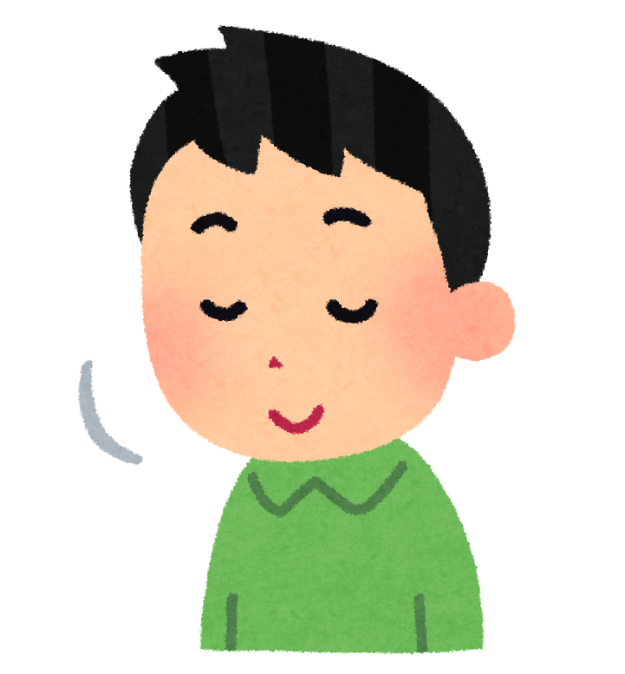

-Yes, I am. I am from Kitakyushu.

-No, I’m not.

|  |  |  |
| --- | --- | --- |
| **13歳**  thirteen  Name: | sleepy  Name: | a soccer fan  Name: |
| in the baseball club  Name: | from Kitakyushu  Name: | **12歳**  twelve  Name: |
| a J-Pop fan  Name: | in the tennis club  Name: | hungry  Name: |